LAB 05

“Hardware Timers”

Spring 2026
Embedded Systems Lab
Submitted by: Naveed Ahmad
Registration No.: 22PWCSE2165
Class Section:B

Student Signature: ______________
Submitted to:
Engr. Muhammad Shahzad
April 22, 2026
Department of Computer Systems Engineering
University of Engineering and Technology, Peshawar
Lab : 05

“Hardware Timers”
Timers:
- Crystal Oscillator / Pulse Generator • Quartz (16MHz)
ATmega328p
- Timers increment automatically with every clock tick
- Like 255 for 8-bit , 65535 for 16 bit
- Generate delays
- Measuring time Intervals
- Producing PWM Signals
- Triggering interrupts at precise intervals Time = timer count * prescaler / clock frequency
e-g:
Timer 0 = 8 bits -> millis , micros , delays
Timer 1 = 16 bits -> Servo libraries , High Resolution PWM
Timer 2 = 8 bits -> Tone Generation
Prescaler:
A numerical frequency divider placed before the timer , It extends the range of the timer so u can measure longer intervals or generate slower frequencies without using huge registers.
Ex:
System Clock = 16 MHz
Prescaler 1 = Timer tick after every 62.5 ns
Prescaler 8 = Timer tick after every 0.5 ns
Prescaler 64 = Timer tick after every 4 ns
Prescaler 1024 = Timer tick after every 64 ns
Without the prescaler the timer will overflow in 4ms with prescaler 1024
Max interval = 65536 * 64 micro S
= 4.2 Sec
TASK 1 :
LED blinks using hardware timers
Void setup(){
Pinmode(13,OUTPUT);
TCCR1A = 0;
TCCR1B = 0;
TCCR1B|= (1<<CS12) (1<<CS10);
}
Void loop(){
If (TCNT1>=15625){ TCNT1=0;
digitalwrite(13,!digitalRead(13));
}
}
• Setting PreScaler:
CS12 = 1
CS11 = 0
CS10 = 1
001 divide by 1
010 divide by 8
011 divide by 64
- divide by 256
- divide by 1024
Task picture :
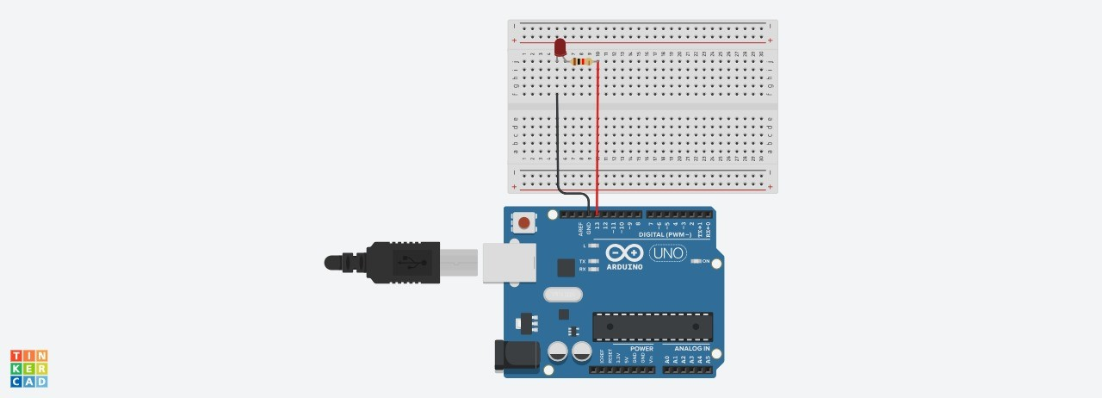
Task 2 :
CODE :
void setup() { pinMode(13, OUTPUT);
TCCR1A = 0;
TCCR1B = 0;
TCCR1B |= (1 << WGM12); // Enable CTC mode
OCR1A = 15624; // Compare value
TCCR1B |= (1 << CS12) | (1 << CS10); // Prescaler = 1024
}
void loop() { if (TIFR1 & (1 << OCF1A)) { // Check compare match flag TIFR1 |= (1 << OCF1A); // Clear flag digitalWrite(13, !digitalRead(13)); // Toggle LED
}
}
Task picture:
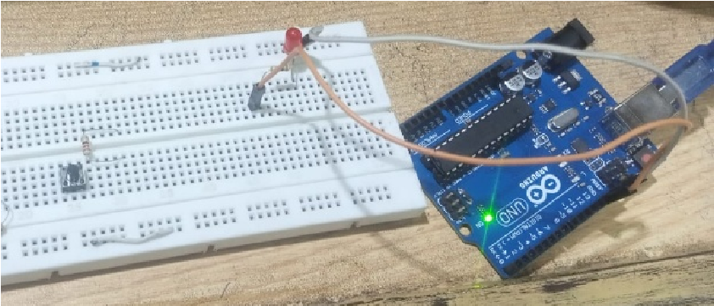
Task 3 :
Code:
const int LED_PIN = 9;
volatile int brightness = 0; volatile int step = 10;
volatile int tickCount = 0; const int TICKS_PER_STEP = 6;
ISR(TIMER2_COMPA_vect) {
tickCount++; if (tickCount < TICKS_PER_STEP) return; tickCount = 0; brightness += step;
if (brightness >= 999) { brightness = 999; step = -10;
} else if (brightness <= 0) { brightness = 0; step = 10; }
OCR1A = brightness;
}
void setup() {
pinMode(LED_PIN, OUTPUT);
TCCR1A = (1 << COM1A1) | (1 << WGM11);
TCCR1B = (1 << WGM13) | (1 << WGM12) | (1 << CS11);
ICR1 = 999; OCR1A = 0;
TCCR2A = (1 << WGM21);
TCCR2B = (1 << CS22) | (1 << CS21) | (1 << CS20);
OCR2A = 255;
TIMSK2 = (1 << OCIE2A);
sei();
}
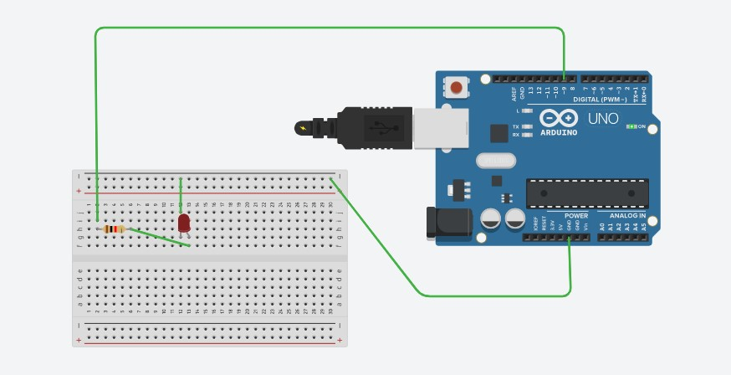
void loop() {
}
Conclusion:
Hardware timers on the ATmega328p enable precise, CPU-independent time control through configurable prescalers and timer registers, allowing applications ranging from simple LED blinking with TCNT1 polling, to accurate CTC-mode compare interrupts, to smooth PWM-driven LED breathing — all without relying on software delays.

